 

INSTITUTE FOR ADVANCED COMPUTING AND

SOFTWARE DEVELOPMENT AKURDI,PUNE

Documentation On

**“Online-Barber Shop Management System”**

PG-DAC SEP 2020

*Submitted By:*

**Group No: 89**

**Name & Roll Number**

**Pranav Sakhare 2152**

**Mithil Chavan 2029**

**Vaibhav Deokar 2035**

**Mrs. Sarika Kankaria Mr. Akhay Parab Centre Coordinator Project Guide**

# Table of Contents

1. Introduction 4
   1. Document Purpose 4
   2. Problem Statement 5
   3. Product Scope 5
   4. Aim & Objectives 5
2. Overall Description 6
   1. Product Perspective 6
   2. Benefits of Online-Barber Shop 6
   3. User and Characteristics 7
   4. Operating Environment 8
   5. Design and Implementation Constraints 9
3. Requirement Specification 9
   1. External Interface Requirements 9
4. System Diagram 11
   1. Activity Diagram 12
   2. Data Flow Diagram 14
   3. Use Case Diagram 17
   4. Class Diagram 18
   5. ER Diagram 19
5. Table Structure 20
   1. Shops 20
   2. Services 20
   3. Slots 20
   4. Users 21
   5. Appointments 21
   6. Appoint_Services 21
   7. Appoints_Slots 21
6. Images of Working Prototype 22
7. Conclusion 26
   1. Future Scope 26
8. References 27

**List of Figures**

Figure 1 Admin Activity Diagram 11

Figure 2 Shop Owner Activity Diagram 12

Figure 3 Customer Activity Diagram 13

Figure 4 Level 0 Data Flow Diagram 14

Figure 5 Level 1 Data Flow Diagram 14

Figure 6 Level 2 Data Flow Diagram for Admin 15

Figure 7 Level 2 Data Flow Diagram for Shop Owner 15

Figure 8 Level 2 Data Flow Diagram for Customer 16

Figure 9 Use Case Diagram 17

Figure 10 Class Diagram 18

Figure 11 ER Diagram 19

# 1. Introduction

The need for hairdressing, grooming, facials, and related services will not decline as long as people live on this earth. In fact, in this age of fashion and corporate culture, people are more interested in grooming themselves than ever before. So, the beauty salons and hairdressing businesses are always on the rise. During this pandemic situation the zero contact policy is much more needed, there is no automated system for doing all the things. Having that in mind, for the people in need of websites for such businesses, so we present you **Online Barber Shop Management System**. Easy to use Barber Shop Management System Software to manage online scheduling, appointment booking and much more!

## Document Purpose

The Online Barber shop for saloon shop web application is intended to provide complete solutions for vendors as well as customers through a single get away using the internet. The E-Barber Shop System allows customer to register and login. After that customer can select the location after selecting the location he can select shop he prefer. He can select the services that he wants from that shop. He can also select multiple services after that he can select the time slot as he prefer and book the appointment. Our E-Barber Shop System streamlines scheduling so that you can make appointments seamless and super organized for everyone.

This E-Barber Shop Management System is developed to provide the following services:

Customer looking for new Barber Shop:

Let customers find Barber Shops in desired area and book appointments easily through popular discovery platforms like reserved with Google, Facebook and Instagram.

Shopkeepers looking for new online platform:

Shopkeeper will get a new platform and will get notified whenever a new appointment is booked, confirmed or cancelled

Customer Schedules Online:

Reduce the scheduling back-and forth with E-Barber Shop System’s 24*7 online booking system. Customers can self-schedule, cancel, reschedule, and book recurring appointments from anywhere.

Shopkeepers track client appointments:

Manage multiple clients, keep track of your client list, setup your daily slots and schedules.

## Problem Statement

Existing system of a Barbershop is based on our traditional way of booking appointments by being present on time. Access of these shops and their services is no longer normal due to the Pandemic situation to people considering the safety. Today due to Pandemic situation the Barber-shops can’t be filled with people waiting in the multi-colored chairs lined up against the wall. Hair salons, can be challenging to maintain proper social distancing and infection prevention measures. The close, face-to-face contact that the work requires for a prolonged period of time, increases risk.

. Hence this system is proposed to overcome the flaws of the existing system and giving power to the customer so that he/she will be able to manage their appointments easily.

## Product Scope

This project traverses a lot of areas ranging from business concept to computing field, and required to perform several researches to be able to achieve the project objectives. The area covers include:

* This includes study on how the daily Barber shop appointment process involved

and opportunity that exist for improvement..

* J2EE Technology used for the development of the application.
* General customers as well as the shop owner will be able to use the system effectively.
* Web-platform means that the system will be available for access 24/724/7 except when there is a temporary server issue which is expected to be minimal..
* Shopkeepers can enlist their shop details on the platform and can gain new customers. Also they can add details of their shops and services.
* Customers can view the list of shops in particular area.

## Aims & Objectives

Specific goals are: -

* To produce a web-based system that allows the customer to book Barber Shop appointment online. Shop owner can view the list of appointments of customer and also can add, update and delete the services.
* To fill the communication gap between customer and shop owner.

# Overall Description

## Product Perspective:

2.1.1 Existing system function:

Existing system to use the Barber Shop services the customer has to go to Barber shop and wait in queue for the barber appointment in shop. The customers do not have a proper way to make an appointment other than making a call or visit the Salon premise. Salon owner, employees and customers need to keep reminders on their mobiles over appointments. Salon owner and her employees maintain a diary to note down the appointment details. Service details of the salon are written on papers which can always lead for misplacements.

* + - **III. PROPOSEDSYSTEM**
    1. Product functionality:

Online-Barber Shop System provides the features for admin, shop owner and customer. It includes several functionalities described as below:

* + - 1. *Admin Management:*

It provides facility to add, update, delete and view the shops. We can view their details and also update the shop details.

* + - 1. *Shop Owner Management:*

The shop owner can view the list of appointments. He can add, update and delete the services. He can add time slots. Shop owner can change the status of shop that is whether shop is on/off for that day.

*Booking the appointment:*

Customer can select the location from drop box. After selecting the location he can select particular shop. He can select the services that he wants. He can also select multiple services after that he can select the time slot as he prefer and book the appointment.

## Benefits of Online-Barber Shop

* This Online-Barber Shop system is fully functional and flexible.
* It is very easy to use.
* This system helps customer to book appointment at barber shop.
* It saves lot of time of customer.
* It increases the efficiency of the management at offering quality services to the customers.

## Users and Characteristics:

* + 1. Admin:
       - Admin can login to the system.
       - View the list of all the register shops.
       - Add new shop.
       - Delete shop.
       - Update shop details.
    2. Customer:
       - Customer can login to the system.
       - Select the location of shop.
       - Can view list of shops at that location.
       - Can select the shop.
       - From selected shop can select multiple services.
       - After selecting services he can select time slot.
       - Can book the appointment.
    3. Shop Owner:
       - Shop owner can login to the system.
       - View appointment list.
       - Add new services.
       - Update services.
       - Delete the services.
       - Add time slot.
       - Delete time slot.
       - Change the status of shop is on/off.

## Operating Environment:

* + 1. Server Side:

**Processor:** Intel Dual Core

**HDD:** Minimum 500GB Disk Space

**RAM:** Minimum 2GB **OS:** Windows 8.1

**Database:** MySQL.

Client Side (minimum requirement):

**Processor:** Intel Dual Core

**HDD:** Minimum 80GB Disk Space

**RAM:** Minimum 1GB

**OS:** Windows 7.

## Design and Implementation Constraints:

* The application will use Spring boot, JavaScript, CSS , Bootstrap as main web technologies.
* HTTP and FTP protocols are used as communication protocols. FTP is used to upload the web application in live domain and the client can access it via HTTP protocol.
* Several types of validations make this web application a secured one and SQL Injections can also be prevented.
* Since Online-Barber Shop System is a web-based application, internet connection must be established.
* The Online-Barber Shop System will be used on PCs and will function via internet or intranet in any web browser.

# Specific Requirement

## External Interface Requirements:

* + 1. User Interfaces:
* All the users will see the same page when they enter in this website. This page asks the users a username and a password.
* After being authenticated by correct username and password, user will be redirected to their corresponding profile where they can do various activities.
* The user interface will be simple and consistent, using terminology commonly understood by intended users of the system. The system will have simple interface, consistence with standard interface, to eliminate need for user training of in frequent users.
  + 1. Hardware Interfaces:
* No extra hardware interfaces are needed.
* The system will use the standard hardware and data communication resources.
* This includes, but not limited to, general network connection at the server/hosting site, network server and network management tools.
  + 1. Application Interfaces:

**OS:** Windows 7,8,10, Linux

**Web Browser:**

The system is a web-based application; clients need a modern web browser such as Mozilla Firebox, Internet Explorer, Opera, or Chrome. The computer must have an Internet connection in order to be able to access the system.

* + 1. Communications Interfaces:
* This system uses communication resources which includes but not limited to, HTTP protocol for communication with the web browser and web server and TCP/IP network protocol with HTTP protocol.
* This application will communicate with the database that holds all the booking information. Users can contact with server side through HTTP protocol by means of a function that is called HTTP Service. This function allows the application to use the data retrieved by server to fulfill the request fired by the user.

# System Design

## 1.Admin activity

## 

**Figure 1: Admin Activity Diagram**

## 2. Shop Owner Activity:

## 

**Figure 2: Shop Owner Activity Diagram**

## 2. Customer Activity:

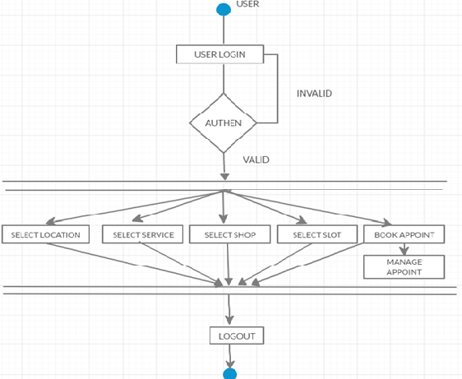

**Figure 3: Customer Activity Diagram**

## Data Flow Diagram



**Figure 4: Level 0 Data Flow Diagram**

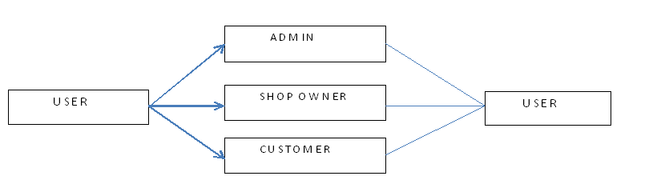

**Figure 5: Level 1 Data Flow Diagram**

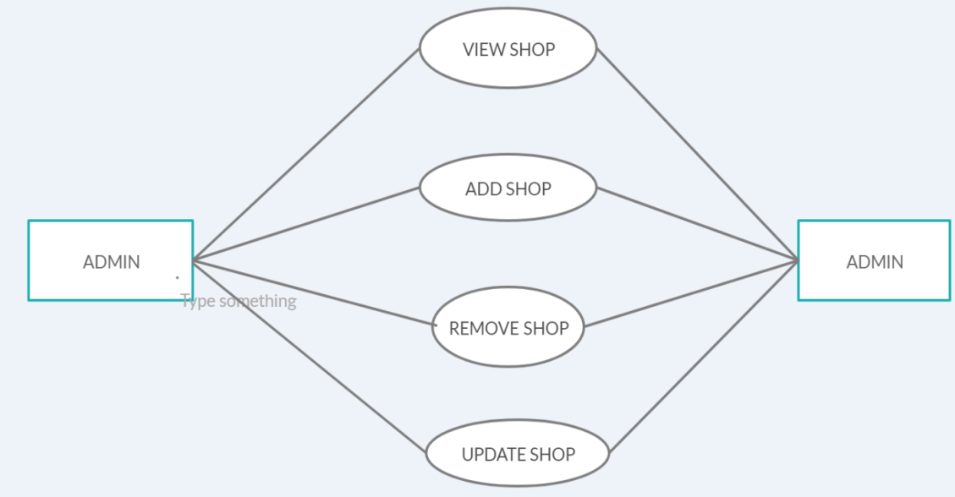

**Figure 6: Level 2 Data Flow Diagram for Admin**

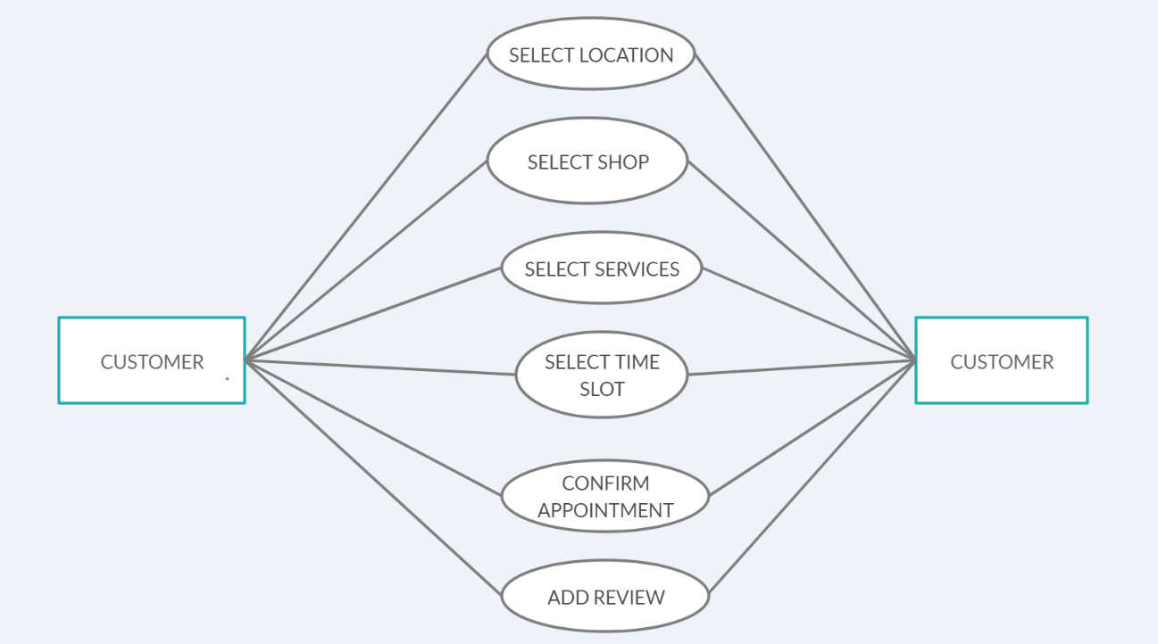

**Figure 7: Level 2 Data Flow Diagram for Customer**

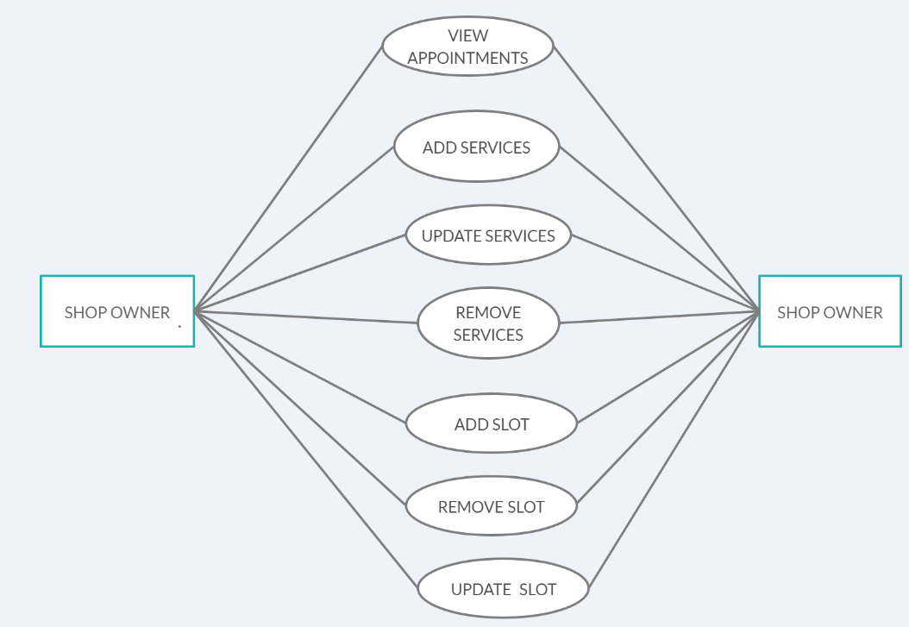

**Figure 8: Level 2 Data Flow Diagram for Shop Owner**

## Use CaseDiagram

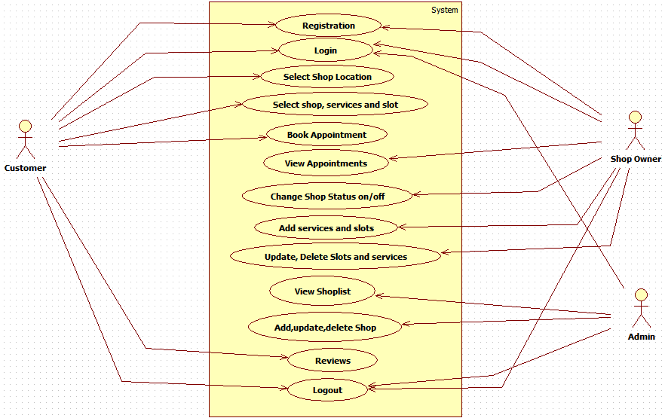

**Figure 9: Use Case Diagram**

## 

## Class Diagram:

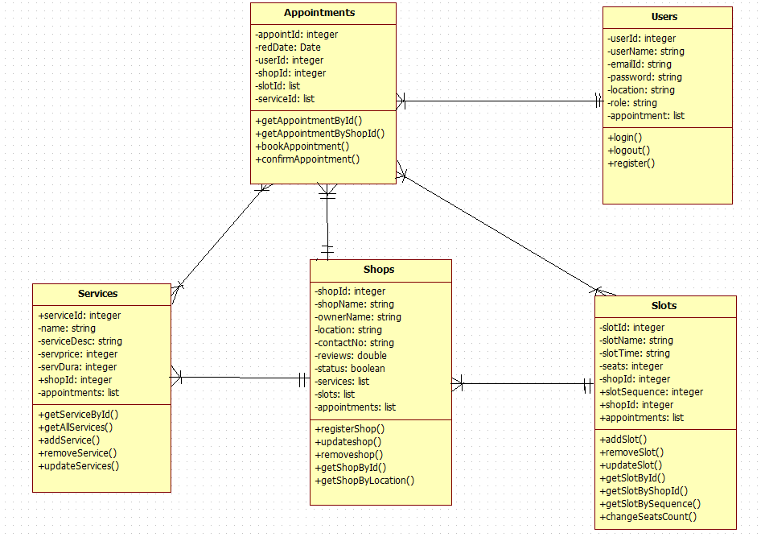

**Figure 10: Class Diagram**

## 

## ERDiagram:

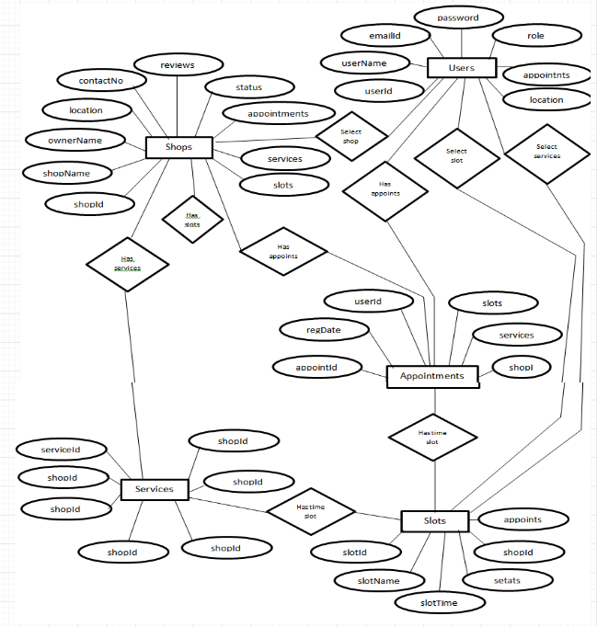

**Figure 11: ER Diagram**

# TableStructure:

## SHOP:

|  |  |  |  |  |  |
| --- | --- | --- | --- | --- | --- |
| Field | Type | Null | Key | Default | Extra |
| shopId | number(11) | NO | PRI | NULL | Auto_increment |
| shopName | varchar2(30) | NO |  | NULL |  |
| ownerName | varchar2(30) | NO | UNI | NULL |  |
| location | varchar2(30) | NO |  | NULL |  |
| contactNumber | number(10) | NO |  | NULL |  |
| status | boolean | NO |  | NULL |  |
| reviews | number(10) | NO |  | NULL |  |

## SERVICES :

|  |  |  |  |  |  |
| --- | --- | --- | --- | --- | --- |
| Field | Type | Null | Key | Default | Extra |
| serviceId | number(11) | NO | PRI | NULL | Auto_increment |
| serviceName | varchar2(50) | NO |  | NULL |  |
| servDesc | varchar2(100) | YES |  | NULL |  |
| ServiceTime | number(10) |  |  | NULL |  |
| servicePrice | number(10) |  |  | NULL |  |
| shopId | number(10) |  | FKEY | NULL |  |

## SLOTS:

|  |  |  |  |  |  |
| --- | --- | --- | --- | --- | --- |
| Field | Type | Null | Key | Default | Extra |
| slotId | number(11) | NO | PRI | NULL | Auto_increment |
| slotName | varchar2(100) | YES |  | NULL |  |
| slotTime | varchar2(100) | NO | UNI | NULL |  |
| chaireAvalable | number(10) | NO |  | NULL |  |
| shopId | number(10) | NO | FKEY | NULL |  |
| slotSequence | number(10) | NO |  | NULL |  |

## 

## USERS:

|  |  |  |  |  |  |
| --- | --- | --- | --- | --- | --- |
| Field | Type | Null | Key | Default | Extra |
| userId | number(11) | NO | PRI | NULL | Auto_increment |
| userName | varchar2(20) | NO |  | NULL |  |
| emailId | varchar2(30) | NO | UNI | NULL |  |
| password | number(10) | NO |  | NULL |  |
| location | varchar2(30) |  |  | NULL |  |
| role | Varchar2(10) |  |  | NULL |  |

## Appointments:

|  |  |  |  |  |  |
| --- | --- | --- | --- | --- | --- |
| Field | Type | Null | Key | Default | Extra |
| appointId | number(11) | NO | PRI | NULL | Auto_increment |
| regDate | Date | NO |  | NULL |  |
| shopId | number(10) |  | FKEY | NULL |  |
| userId | number(10) |  | FKEY | NULL |  |

## appoints_services:

|  |  |  |  |  |  |
| --- | --- | --- | --- | --- | --- |
| Field | Type | Null | Key | Default | Extra |
| appointId | number(11) | NO |  | NULL |  |
| serviceId | number(11) | NO |  | NULL |  |

## appoints_slots:

|  |  |  |  |  |  |
| --- | --- | --- | --- | --- | --- |
| Field | Type | Null | Key | Default | Extra |
| appointId | number(11) | NO |  | NULL |  |
| slotsId | number(11) | NO |  | NULL |  |

# Images of Working Prototype

# Home Page:

# 

# Login Page:

# 

# Registration Page:

# 

# 

# Admin Functionalities:

# 

# 

# Shopkeeper Functionalities:

# 

# Add new Services:

# 

# Add New Slot:

# 

# Added Services List:

# 

# Added Slots List:

# 

# Customer Functionality:

# Select Location:

# 

# 

# Select Shop:

# 

# Select Service:

# Select Slot:

# 

# 

# Selected Service And Slot:

# 

# 

# Appointment Booked Successfully:

# 

# 

**Conclusion**

Online-Barber Shop system is responsible for providing best services, flexible time slot and daily services and time changes with the affordable prices on specified. This approach also offers an added advantage that customers can select a specified time slot of the day for the appointments of shop. The application provides facility to add/remove/slot and services items at shop. It also provides facility where customers can mention their queries/complaints in reviews. Application provides safety and reduces risk during the pandemic situation.

.

# Future Scope

This project can be enhanced further by adding other categories and Services. The software is flexible enough to be modified and implemented as per future requirements. Message and Email alerts for various happenings can be added to the system so that users do not miss the updates and happenings of the system.

# References

[1]. Kirti Bhandge, Tejas Shinde, Dheeraj Ingale, Neeraj Solanki, Reshma Totare,”A Proposed System for Touchpad Based Barber shop System Using Android Application”, International Journal of Advanced Research in Computer Science Technology (IJARCST 2015).

[2]. Varsha Chavan, Priya Jadhav,Snehal Korade,Priyanka Teli, ”Implementing Customizable Online Barber shop System Using Web Based Application”, International Journal of Innovative Science, Engineering Technology(IJISET) 2015.

**ONLINE REFERENCE**

1. [www.salonist.in/](http://www.salonist.in/)
2. <https://docs.oracle.com/javase/tutorial/>